Salesforce Trigger and controllers Assignment

**Trigger Assignment**

**Ques 1: How to create triggers? Explain with Example.**

**Ans:** A trigger in Salesforce is a piece of Apex code that is executed before or after specific database events, such as insert, update, delete, or undelete, on a record. Triggers are created on objects and are stored as metadata.

**Steps to Create a Trigger:**

1. Navigate to **Setup** → **Object Manager** → Choose the Object (e.g., Account).
2. Go to **Triggers** under the object settings.
3. Click **New** to create a trigger.

**Syntax:** trigger TriggerName on ObjectName (trigger_events) {

// Trigger logic here

}

**Example:**

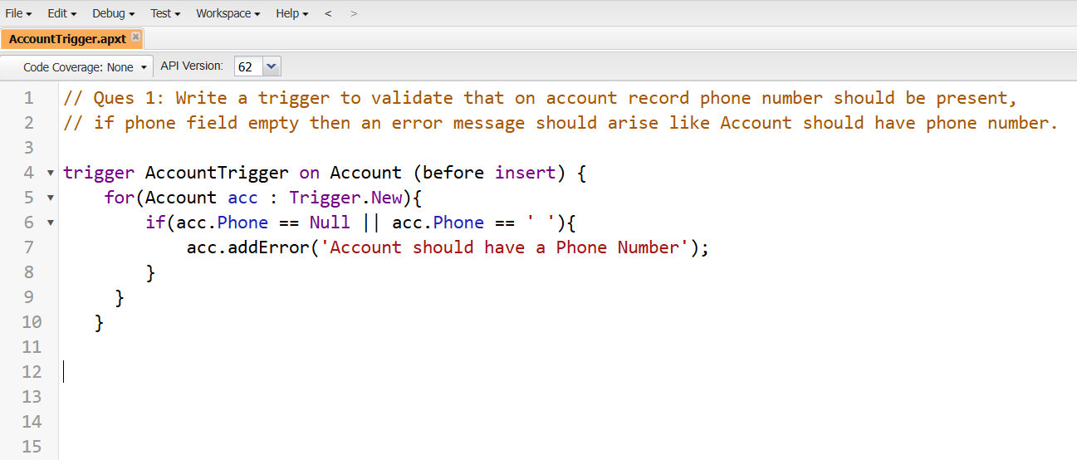

**Output:**

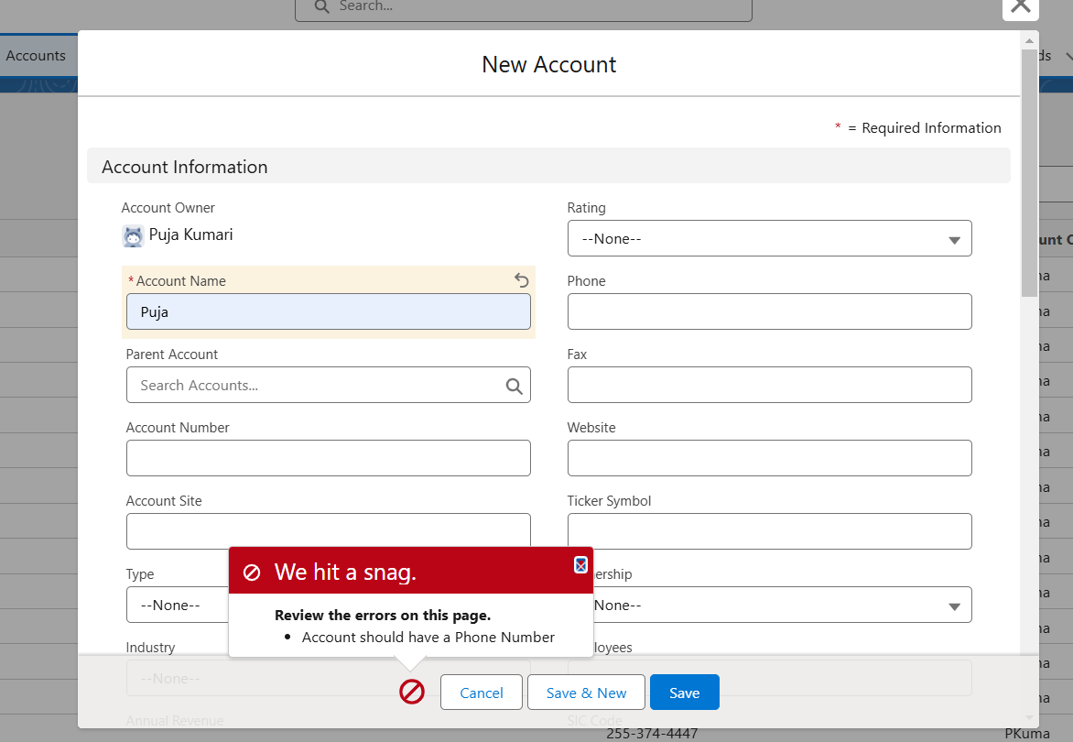

**Ques 2: Write a trigger example to insert contact when you create account.**

**Ans: Trigger**

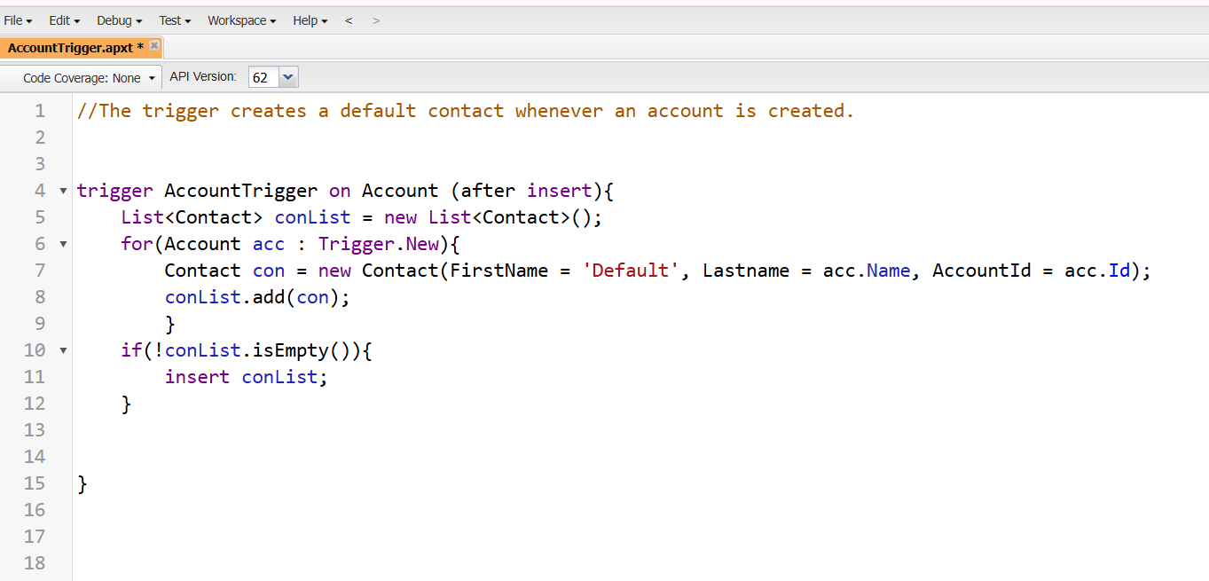

**Output:-**

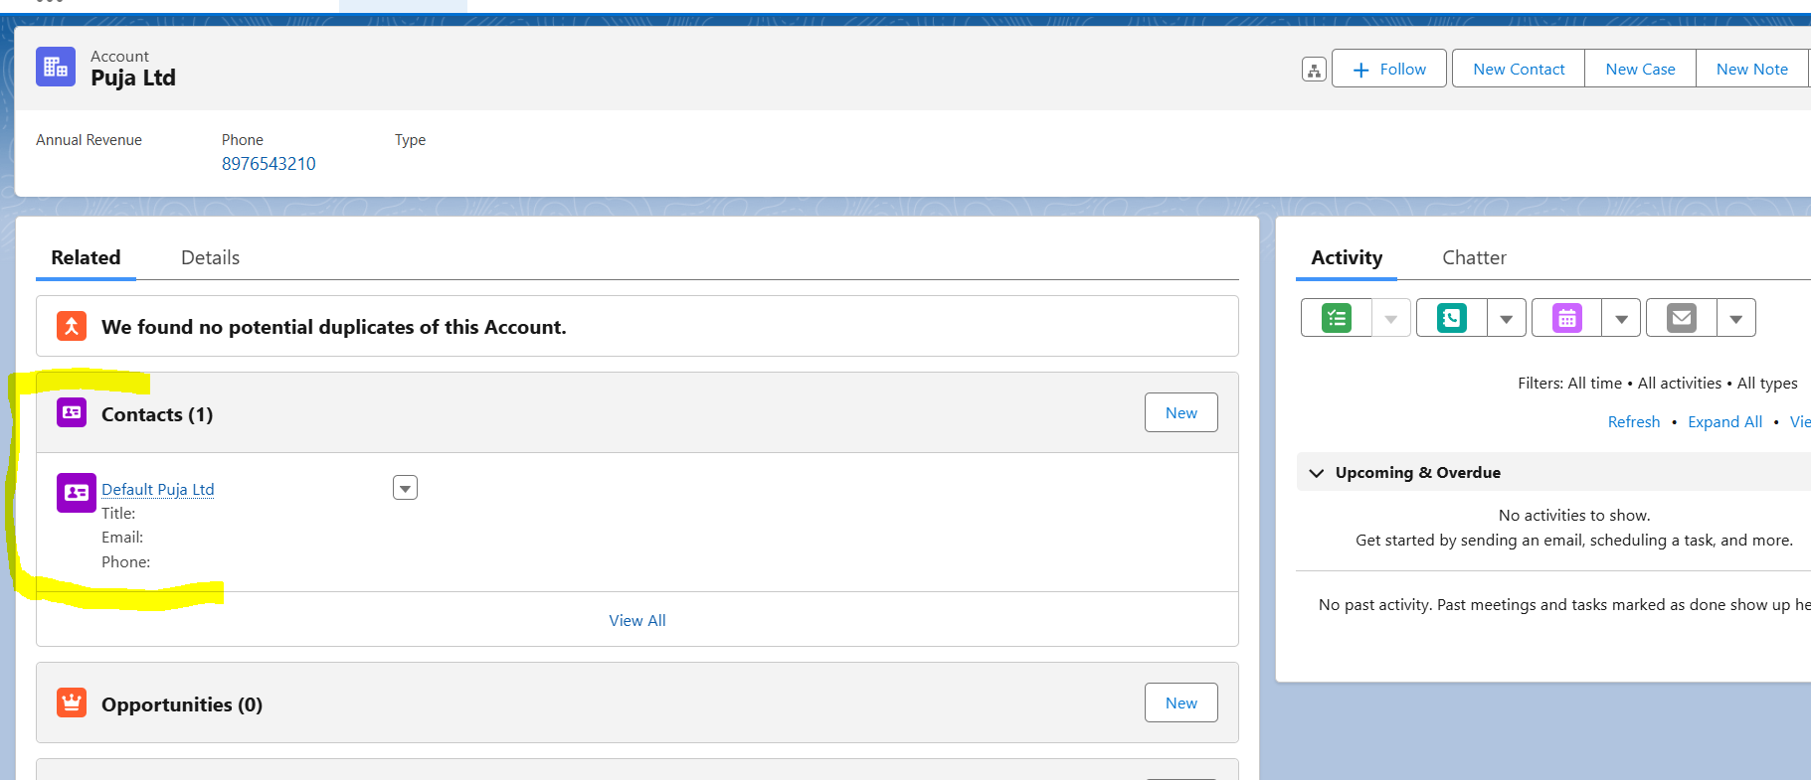

**Ques 3: Explain Trigger.oldmap with example.**

**Ans: Trigger.oldMap** is a map of IDs to the old versions of the records that were updated or deleted. It is available in the following contexts:

* **update (before and after)**
* **delete (before and after)**

**Example:** Compare the old and new values of a field during an update:

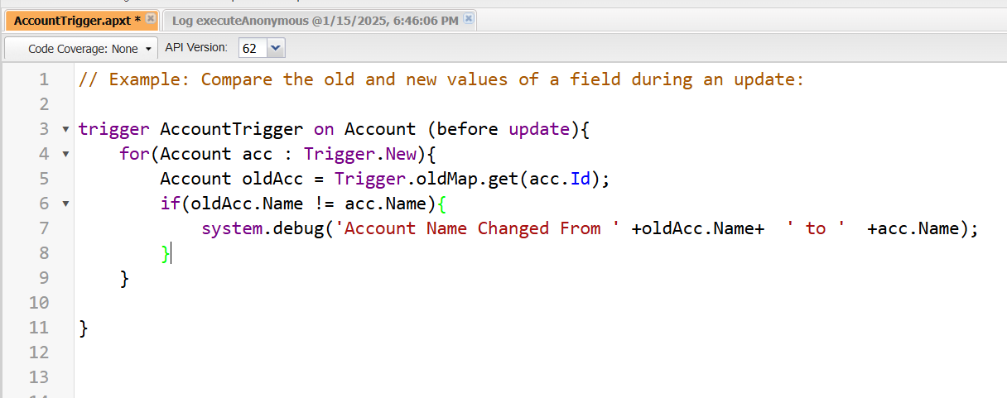

**Output:**

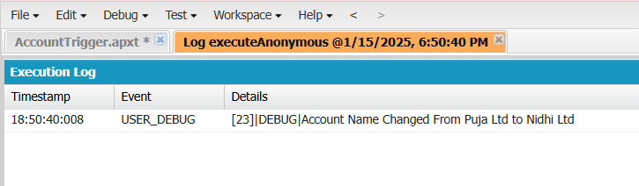

**Ques 4: Write an example to create list in Apex Trigger.**

**Ans:** 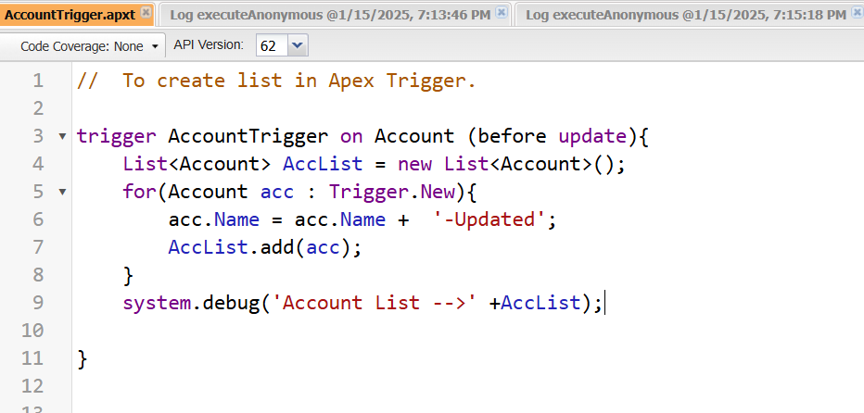

**Output:**





**Ques 5: Write an example to create Set & Map in Apex Trigger.**

**Ans:** Following is the example to create set and map on Account Object

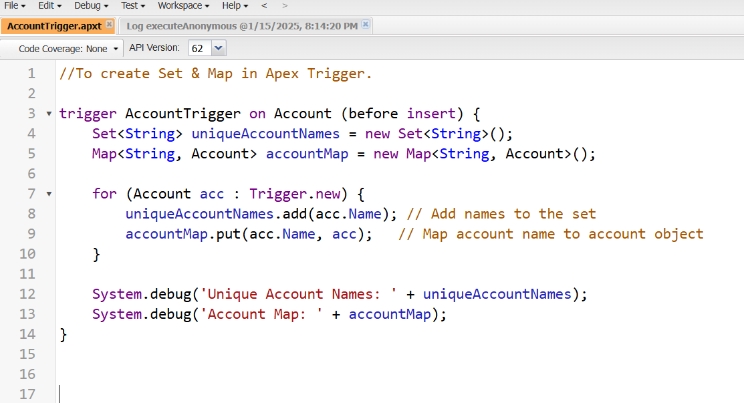

**Output:**

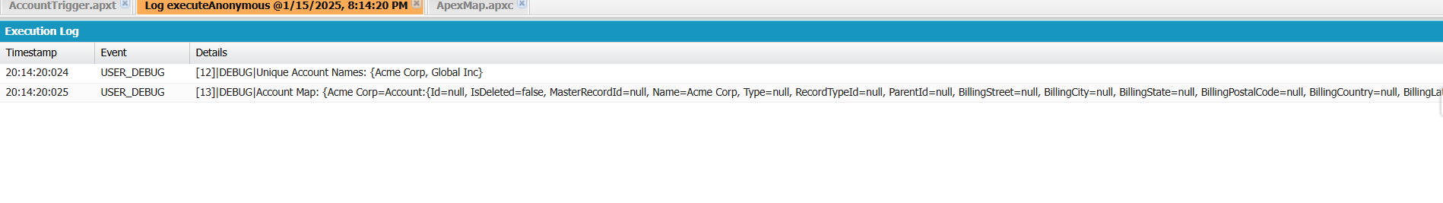

**Controller Assignment**

**Ques 1: Design VisualForce Page using Custom Controller Class.**

**Ans:**

**MyCustomController Apex Class:**

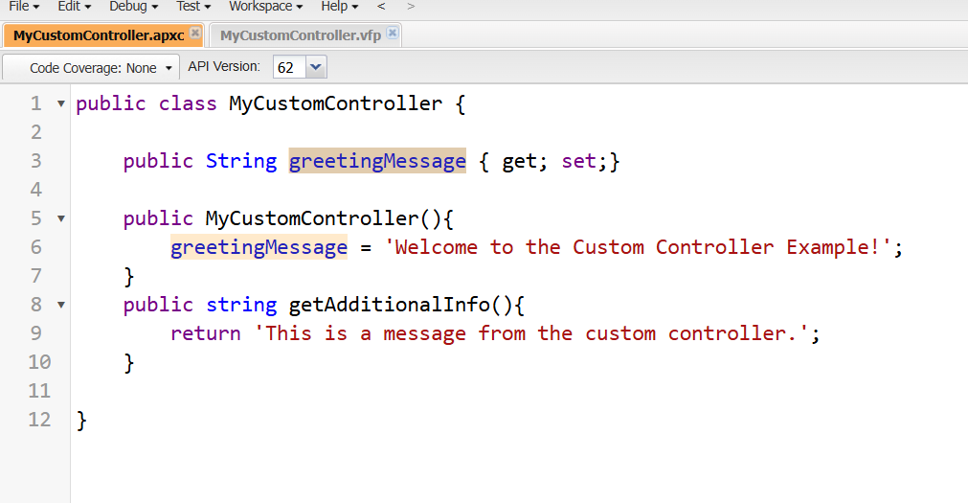

**MyCustomController Visualforce Page:**

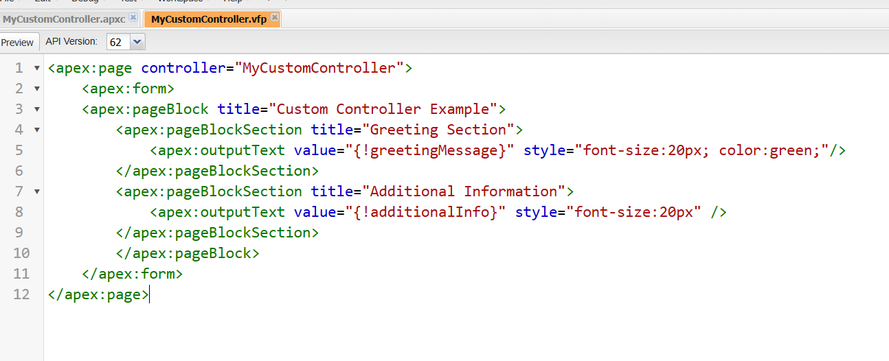

**Output:**

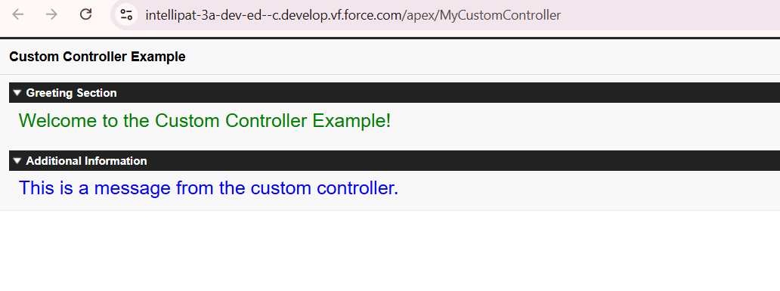

**Ques 2: Design VisualForce Page using Custom Controller Extensions Class ?**

**Ans:**

**MyCustomController Apex Class**

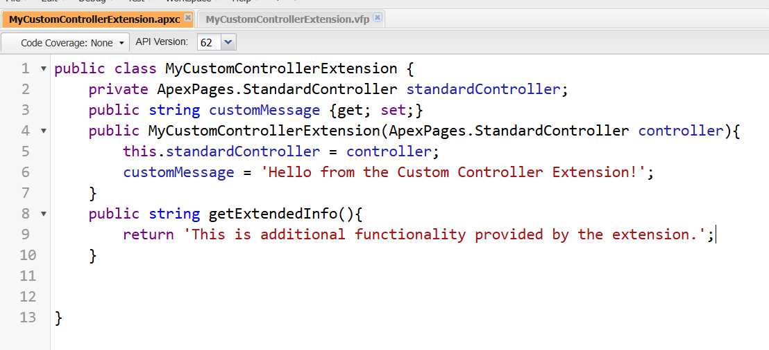

**MyCustomController Visualforce Page:**

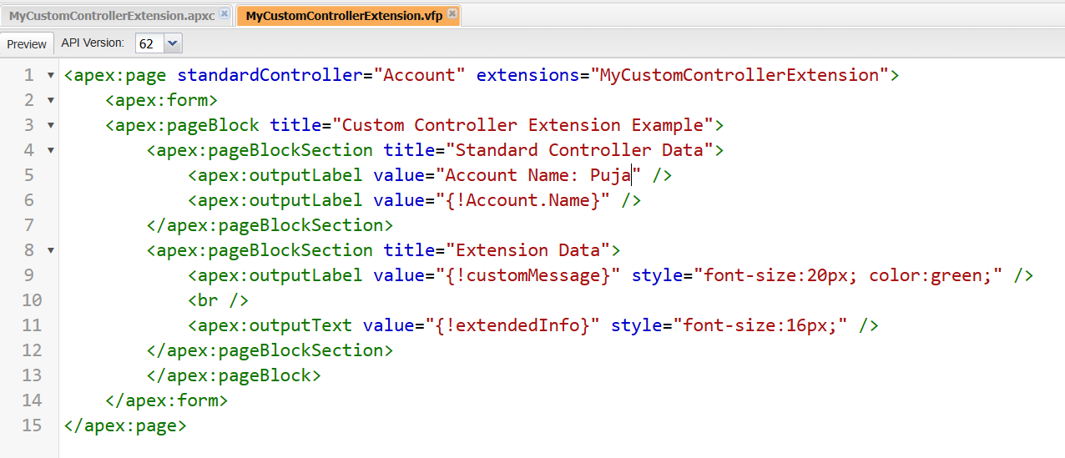

**Output:**

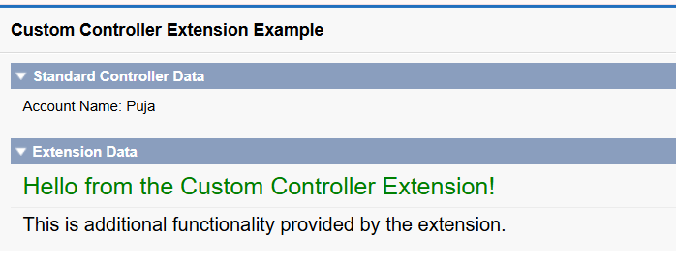

**Ques 3: Write an example to create new records using custom controller.**

**Ans:**

**AccountCreationController Apex Class**

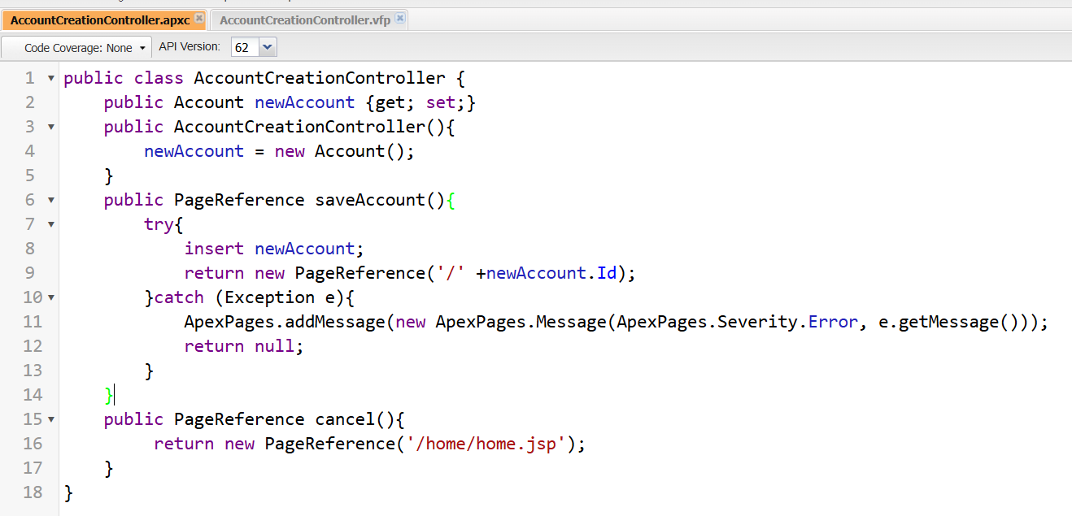

**AccountCreationController VisualForce Page**

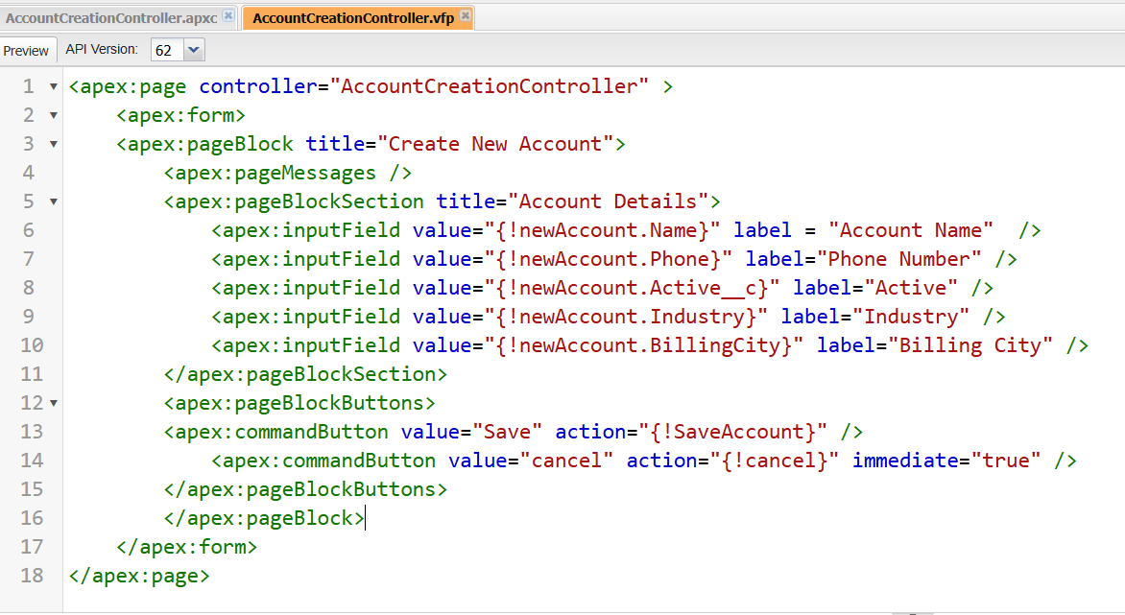

**Output:**

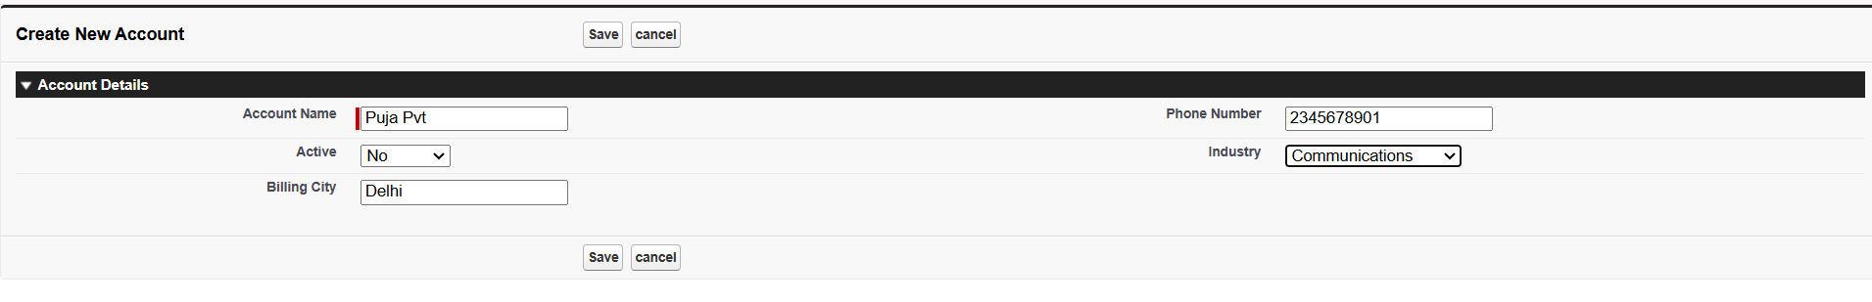

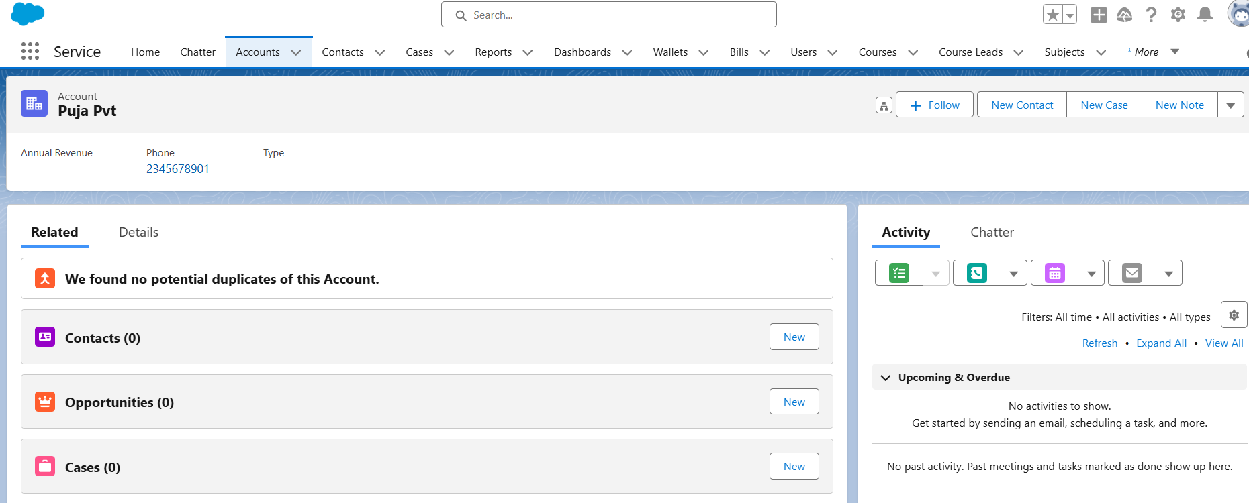

**Ques 4: Write an example to manage list of records by using standard controller.**

**Ans:**

**AccountStandardController VisualForce Paage**

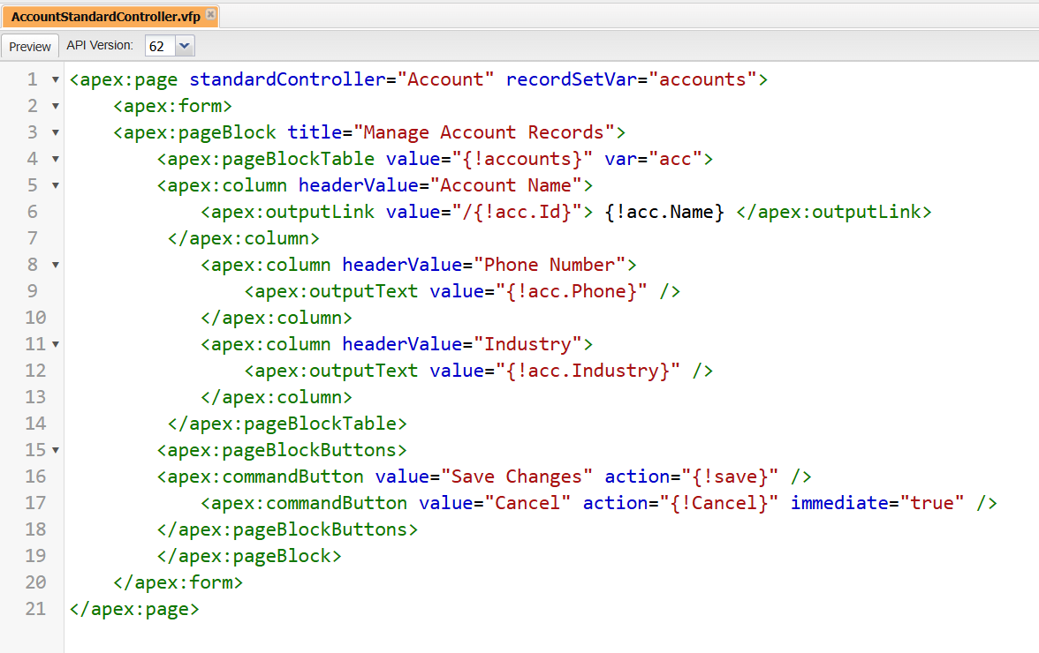

**Output:**

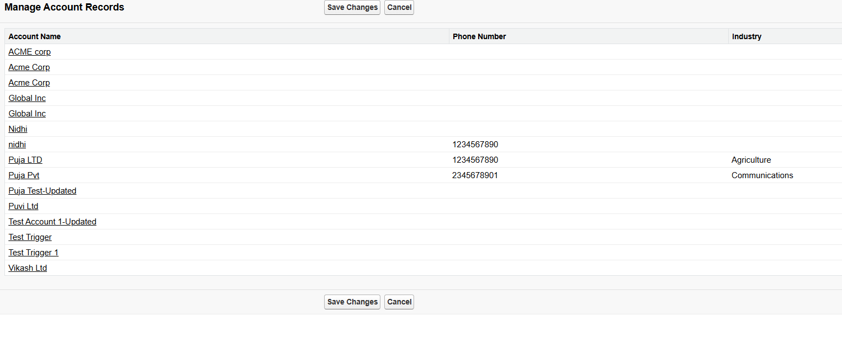

**Ques 5: Explain Rendered Function with example.**

**Ans:** The **rendered** attribute in Visualforce determines whether a specific component is displayed on the page. The attribute accepts a Boolean expression, and the component is only displayed if the expression evaluates to **true**.

**Apex Controller Code**

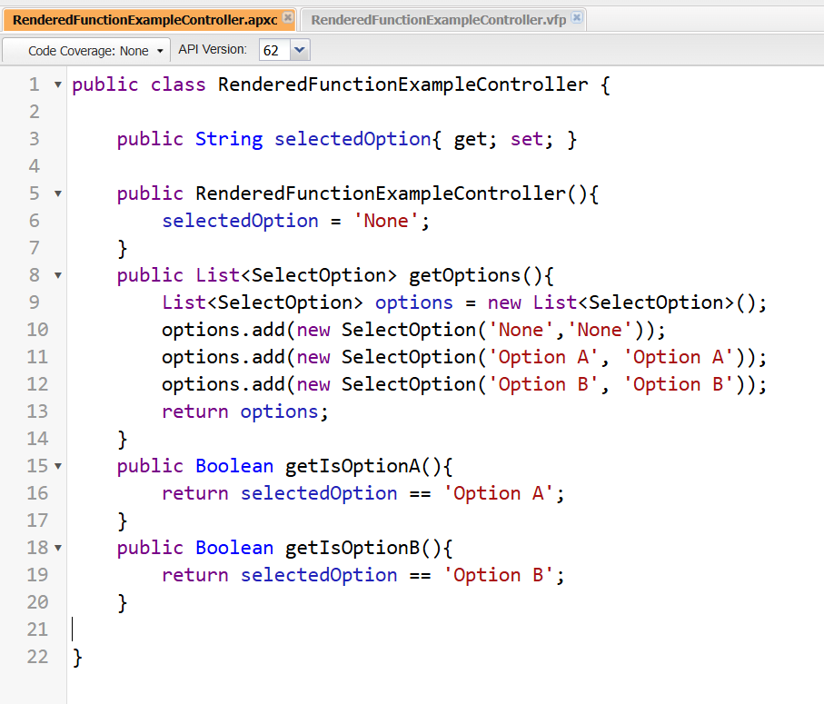

**Visualforce Page Code**

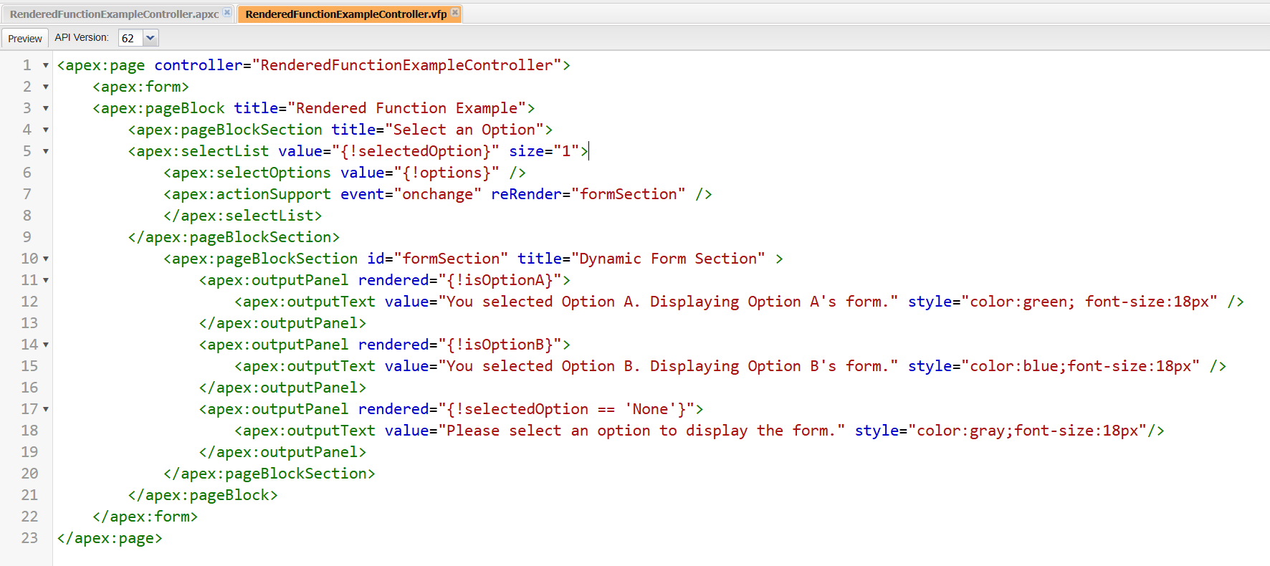

**Outputs**

**For None:**

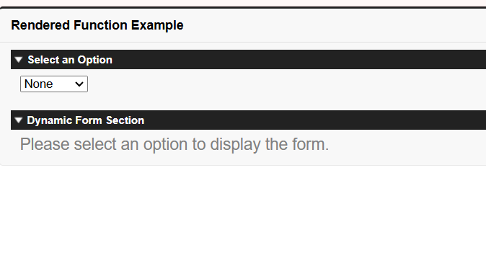

**For Option A:**

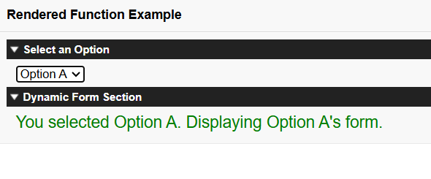

**For Option B:**

